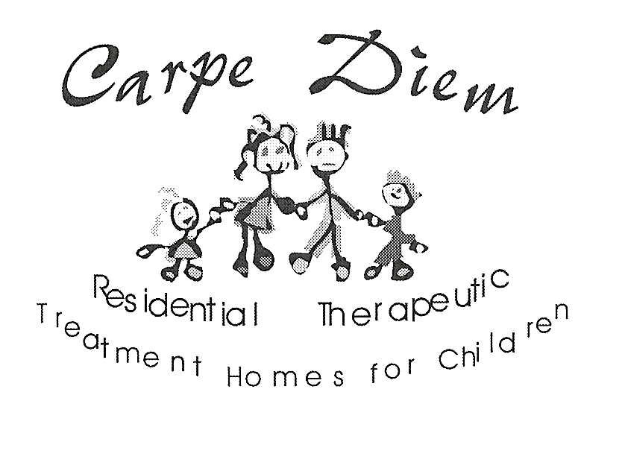

STATEMENT OF CONFIDENTIALITY
(Understanding and Agreement Respecting Secrecy)

I understand that some of the information and documents with which I will be working may be confidential, and that it is expected, of me, that they should be safeguarded.

I agree that, except as I may be legally authorized or required, I will not disclose, or give to any person, any information or document that comes to my knowledge, or my possession, by reason of my participation in the service of Carpe Diem Residential Treatment Homes for Children Inc.

I accept this condition of being in the employ of Carpe Diem Residential Treatment Homes for Children Inc.

_____________________________/___________/______________________________
Signature Date Name (please print)

____________________________/ ___________/ _______________________________
Signature Date Name (please print)

_____________________________/___________/______________________________
Witness Date Name (please print)

